**Title of the Project: Car Showroom Website**

**Group Number: 07**

**Group Members: 03**

|  |  |
| --- | --- |
| **Student ID** | **Student Name** |
| 18101140 | SOWAT HOSSAIN RAFI |
| 18101142 | SHOVON MANDAL |
| 18101047 | AFIF BIN JINNAT |

**State Machine Diagram for Customer object (Book and Buy Car)**

Figure 1 out of 2

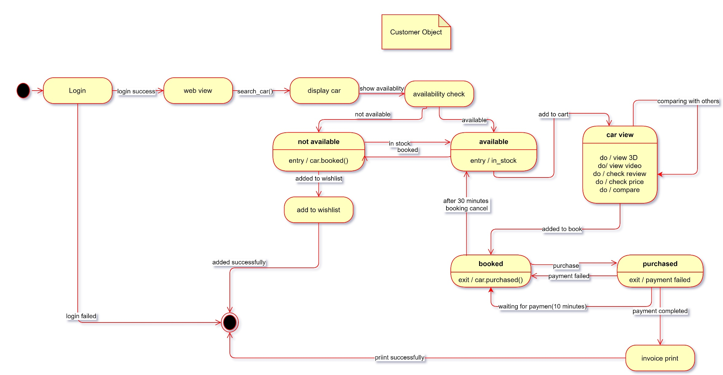

**State Machine Diagram for Admin object (Add and Update Car)**

Figure 2 out of 2

